Problem Solving
In previous math courses, you’ve no doubt run into the infamous “word problems.” Unfortunately, these problems rarely resemble the type of problems we actually encounter in everyday life. In math books, you usually are told exactly which formula or procedure to use, and are given exactly the information you need to answer the question. In real life, problem solving requires identifying an appropriate formula or procedure, and determining what information you will need (and won’t need) to answer the question.

In this chapter, we will review several basic but powerful algebraic ideas: percents, rates, and proportions. We will then focus on the problem solving process, and explore how to use these ideas to solve problems where we don’t have perfect information.

Percents
In the 2004 vice-presidential debates, Edwards's claimed that US forces have suffered "90% of the coalition casualties" in Iraq. Cheney disputed this, saying that in fact Iraqi security forces and coalition allies "have taken almost 50 percent" of the casualties. Who is correct? How can we make sense of these numbers?

Percent literally means “per 100,” or “parts per hundred.” When we write 40%, this is equivalent to the fraction 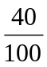 or the decimal 0.40. Notice that 80 out of 200 and 10 out of 25 are also 40%, since 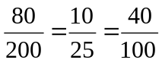.

Example 1
243 people out of 400 state that they like dogs. What percent is this?

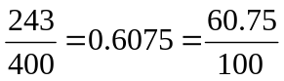. This is 60.75%.

Notice that the percent can be found from the equivalent decimal by moving the decimal point two places to the right.

Example 2
Write each as a percent: a)  b) 0.02 c) 2.35

a) 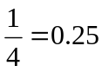 = 25% b) 0.02 = 2% c) 2.35 = 235%

Percents
If we have a part that is some percent of a whole, then
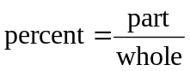, or equivalently, 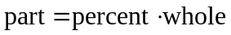
To do the calculations, we write the percent as a decimal.

Example 3
The sales tax in a town is 9.4%. How much tax will you pay on a $140 purchase?

Here, $140 is the whole, and we want to find 9.4% of $140. We start by writing the percent as a decimal by moving the decimal point two places to the left (which is equivalent to dividing by 100). We can then compute:
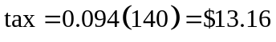 in tax.

Example 4
In the news, you hear “tuition is expected to increase by 7% next year.” If tuition this year was $1200 per quarter, what will it be next year?

The tuition next year will be the current tuition plus an additional 7%, so it will be 107% of this year’s tuition:
$1200(1.07) = $1284.

Alternatively, we could have first calculated 7% of $1200: $1200(0.07) = $84.

Notice this is not the expected tuition for next year (we could only wish). Instead, this is the expected increase, so to calculate the expected tuition, we’ll need to add this change to the previous year’s tuition:
$1200 + $84 = $1284.

Try it Now 1
A TV originally priced at $799 is on sale for 30% off. There is then a 9.2% sales tax. Find the price after including the discount and sales tax.

Example 5
The value of a car dropped from $7400 to $6800 over the last year. What percent decrease is this?

To compute the percent change, we first need to find the dollar value change: $6800-$7400 = -$600. Often we will take the absolute value of this amount, which is called the absolute change: 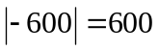.
Since we are computing the decrease relative to the starting value, we compute this percent out of $7400:
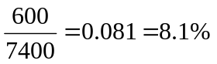 decrease. This is called a relative change.

Absolute and Relative Change
Given two quantities,
Absolute change = 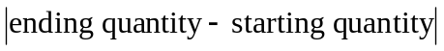
Relative change: 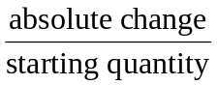

Absolute change has the same units as the original quantity.
Relative change gives a percent change.
The starting quantity is called the base of the percent change.

The base of a percent is very important. For example, while Nixon was president, it was argued that marijuana was a “gateway” drug, claiming that 80% of marijuana smokers went on to use harder drugs like cocaine. The problem is, this isn’t true. The true claim is that 80% of harder drug users first smoked marijuana. The difference is one of base: 80% of marijuana smokers using hard drugs, vs. 80% of hard drug users having smoked marijuana. These numbers are not equivalent. As it turns out, only one in 2,400 marijuana users actually go on to use harder drugs.

Example 6
There are about 75 QFC supermarkets in the U.S. Albertsons has about 215 stores. Compare the size of the two companies.

When we make comparisons, we must ask first whether an absolute or relative comparison. The absolute difference is 215 – 75 = 140. From this, we could say “Albertsons has 140 more stores than QFC.” However, if you wrote this in an article or paper, that number does not mean much. The relative difference may be more meaningful. There are two different relative changes we could calculate, depending on which store we use as the base:

Using QFC as the base, 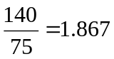.
This tells us Albertsons is 186.7% larger than QFC.
Using Albertsons as the base, 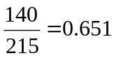.
This tells us QFC is 65.1% smaller than Albertsons.

Notice both of these are showing percent differences. We could also calculate the size of Albertsons relative to QFC: 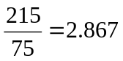, which tells us Albertsons is 2.867 times the size of QFC. Likewise, we could calculate the size of QFC relative to Albertsons: 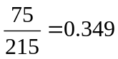, which tells us that QFC is 34.9% of the size of Albertsons.

Example 7
Suppose a stock drops in value by 60% one week, then increases in value the next week by 75%. Is the value higher or lower than where it started?

To answer this question, suppose the value started at $100. After one week, the value dropped by 60%:
$100 - $100(0.60) = $100 - $60 = $40.

In the next week, notice that base of the percent has changed to the new value, $40. Computing the 75% increase:
$40 + $40(0.75) = $40 + $30 = $70.

In the end, the stock is still $30 lower, or 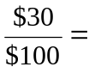30% lower, valued than it started.

Try it Now 2
The U.S. federal debt at the end of 2001 was $5.77 trillion, and grew to $6.20 trillion by the end of 2002. At the end of 2005 it was $7.91 trillion, and grew to $8.45 trillion by the end of 2006. Calculate the absolute and relative increase for 2001-2002 and 2005-2006. Which year saw a larger increase in federal debt?

Example 8
A Seattle Times article on high school graduation rates reported “The number of schools graduating 60 percent or fewer students in four years – sometimes referred to as “dropout factories” – decreased by 17 during that time period. The number of kids attending schools with such low graduation rates was cut in half.”

a) Is the “decrease by 17” number a useful comparison?

b) Considering the last sentence, can we conclude that the number of “dropout factories” was originally 34?

a) This number is hard to evaluate, since we have no basis for judging whether this is a larger or small change. If the number of “dropout factories” dropped from 20 to 3, that’d be a very significant change, but if the number dropped from 217 to 200, that’d be less of an improvement.

b) The last sentence provides relative change which helps put the first sentence in perspective. We can estimate that the number of “dropout factories” was probably previously around 34. However, it’s possible that students simply moved schools rather than the school improving, so that estimate might not be fully accurate.

Example 9
In the 2004 vice-presidential debates, Edwards's claimed that US forces have suffered "90% of the coalition casualties" in Iraq. Cheney disputed this, saying that in fact Iraqi security forces and coalition allies "have taken almost 50 percent" of the casualties. Who is correct?

Without more information, it is hard for us to judge who is correct, but we can easily conclude that these two percents are talking about different things, so one does not necessarily contradict the other. Edward’s claim was a percent with coalition forces as the base of the percent, while Cheney’s claim was a percent with both coalition and Iraqi security forces as the base of the percent. It turns out both statistics are in fact fairly accurate.

Try it Now 3
In the 2012 presidential elections, one candidate argued that “the president’s plan will cut $716 billion from Medicare, leading to fewer services for seniors,” while the other candidate rebuts that “our plan does not cut current spending and actually expands benefits for seniors, while implementing cost saving measures.” Are these claims in conflict, in agreement, or not comparable because they’re talking about different things?

We’ll wrap up our review of percents with a couple cautions. First, when talking about a change of quantities that are already measured in percents, we have to be careful in how we describe the change.

Example 10
A politician’s support increases from 40% of voters to 50% of voters. Describe the change.

We could describe this using an absolute change: 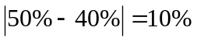. Notice that since the original quantities were percents, this change also has the units of percent. In this case, it is best to describe this as an increase of 10 percentage points.

In contrast, we could compute the percent change: 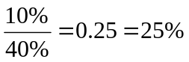 increase. This is the relative change, and we’d say the politician’s support has increased by 25%.
Lastly, a caution against averaging percents.

Example 11
A basketball player scores on 40% of 2-point field goal attempts, and on 30% of 3-point of field goal attempts. Find the player’s overall field goal percentage.

It is very tempting to average these values, and claim the overall average is 35%, but this is likely not correct, since most players make many more 2-point attempts than 3-point attempts. We don’t actually have enough information to answer the question. Suppose the player attempted 200 2-point field goals and 100 3-point field goals. Then they made 200(0.40) = 80 2-point shots and 100(0.30) = 30 3-point shots. Overall, they made 110 shots out of 300, for a 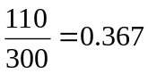 = 36.7% overall field goal percentage.

Proportions and Rates
If you wanted to power the city of Seattle using wind power, how many windmills would you need to install? Questions like these can be answered using rates and proportions.

Rates
A rate is the ratio (fraction) of two quantities.
A unit rate is a rate with a denominator of one.

Example 12
Your car can drive 300 miles on a tank of 15 gallons. Express this as a rate.
Expressed as a rate, 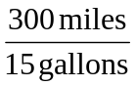. We can divide to find a unit rate: 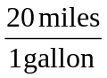, which we could also write as 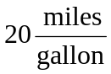, or just 20 miles per gallon.

Proportion Equation
A proportion equation is an equation showing the equivalence of two rates or ratios.

Example 13
Solve the proportion 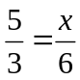 for the unknown value x.

This proportion is asking us to find a fraction with denominator 6 that is equivalent to the fraction . We can solve this by multiplying both sides of the equation by 6, giving
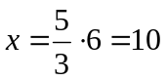.
Example 14
A map scale indicates that ½ inch on the map corresponds with 3 real miles. How many miles apart are two cities that are 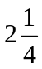 inches apart on the map?

We can set up a proportion by setting equal two 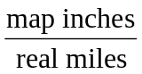 rates, and introducing a variable, x, to represent the unknown quantity – the mile distance between the cities.
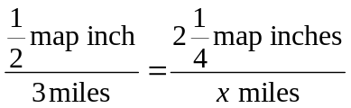 Multiply both sides by x
and rewriting the mixed number
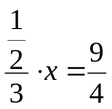 Multiply both sides by 3
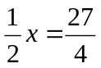 Multiply both sides by 2 (or divide by ½)
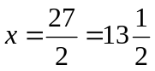 miles

Many proportion problems can also be solved using dimensional analysis, the process of multiplying a quantity by rates to change the units.

Example 15
Your car can drive 300 miles on a tank of 15 gallons. How far can it drive on 40 gallons?

We could certainly answer this question using a proportion: 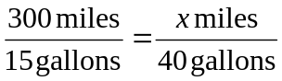.

However, we earlier found that 300 miles on 15 gallons gives a rate of 20 miles per gallon. If we multiply the given 40 gallon quantity by this rate, the gallons unit “cancels” and we’re left with a number of miles:
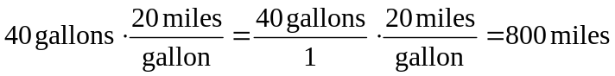

Notice if instead we were asked “how many gallons are needed to drive 50 miles?” we could answer this question by inverting the 20 mile per gallon rate so that the miles unit cancels and we’re left with gallons:

Dimensional analysis can also be used to do unit conversions. Here are some unit conversions for reference.

Unit Conversions
Length
1 foot (ft) = 12 inches (in) 1 yard (yd) = 3 feet (ft)
1 mile = 5,280 feet
1000 millimeters (mm) = 1 meter (m) 100 centimeters (cm) = 1 meter
1000 meters (m) = 1 kilometer (km) 2.54 centimeters (cm) = 1 inch

Weight and Mass
1 pound (lb) = 16 ounces (oz) 1 ton = 2000 pounds
1000 milligrams (mg) = 1 gram (g) 1000 grams = 1kilogram (kg)
1 kilogram = 2.2 pounds (on earth)

Capacity
1 cup = 8 fluid ounces (fl oz)* 1 pint = 2 cups
1 quart = 2 pints = 4 cups 1 gallon = 4 quarts = 16 cups
1000 milliliters (ml) = 1 liter (L)

*Fluid ounces are a capacity measurement for liquids. 1 fluid ounce ≈ 1 ounce (weight) for water only.

Example 16
A bicycle is traveling at 15 miles per hour. How many feet will it cover in 20 seconds?

To answer this question, we need to convert 20 seconds into feet. If we know the speed of the bicycle in feet per second, this question would be simpler. Since we don’t, we will need to do additional unit conversions. We will need to know that 5280 ft = 1 mile. We might start by converting the 20 seconds into hours:
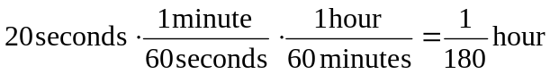 Now we can multiply by the 15 miles/hr
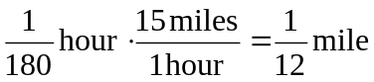 Now we can convert to feet
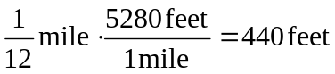

We could have also done this entire calculation in one long set of products:

Try it Now 4
A 1000 foot spool of bare 12-gauge copper wire weighs 19.8 pounds. How much will 18 inches of the wire weigh, in ounces?
Notice that with the miles per gallon example, if we double the miles driven, we double the gas used. Likewise, with the map distance example, if the map distance doubles, the real-life distance doubles. This is a key feature of proportional relationships, and one we must confirm before assuming two things are related proportionally.

Example 17
Suppose you’re tiling the floor of a 10 ft by 10 ft room, and find that 100 tiles will be needed. How many tiles will be needed to tile the floor of a 20 ft by 20 ft room?

In this case, while the width the room has doubled, the area has quadrupled. Since the number of tiles needed corresponds with the area of the floor, not the width, 400 tiles will be needed. We could find this using a proportion based on the areas of the rooms:
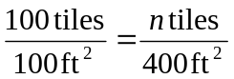

Other quantities just don’t scale proportionally at all.

Example 18
Suppose a small company spends $1000 on an advertising campaign, and gains 100 new customers from it. How many new customers should they expect if they spend $10,000?

While it is tempting to say that they will gain 1000 new customers, it is likely that additional advertising will be less effective than the initial advertising. For example, if the company is a hot tub store, there are likely only a fixed number of people interested in buying a hot tub, so there might not even be 1000 people in the town who would be potential customers.

Sometimes when working with rates, proportions, and percents, the process can be made more challenging by the magnitude of the numbers involved. Sometimes, large numbers are just difficult to comprehend.

Example 19
Compare the 2010 U.S. military budget of $683.7 billion to other quantities.

Here we have a very large number, about $683,700,000,000 written out. Of course, imagining a billion dollars is very difficult, so it can help to compare it to other quantities.

If that amount of money was used to pay the salaries of the 1.4 million Walmart employees in the U.S., each would earn over $488,000.

There are about 300 million people in the U.S. The military budget is about $2,200 per person.

If you were to put $683.7 billion in $100 bills, and count out 1 per second, it would take 216 years to finish counting it.

Example 20
Compare the electricity consumption per capita in China to the rate in Japan.

To address this question, we will first need data. From the CIA website we can find the electricity consumption in 2011 for China was 4,693,000,000,000 KWH (kilowatt-hours), or 4.693 trillion KWH, while the consumption for Japan was 859,700,000,000, or 859.7 billion KWH. To find the rate per capita (per person), we will also need the population of the two countries. From the World Bank, we can find the population of China is 1,344,130,000, or 1.344 billion, and the population of Japan is 127,817,277, or 127.8 million.

Computing the consumption per capita for each country:
China: 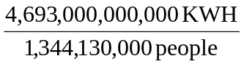 ≈ 3491.5 KWH per person
Japan: 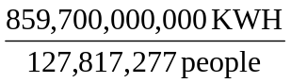 ≈ 6726 KWH per person

While China uses more than 5 times the electricity of Japan overall, because the population of Japan is so much smaller, it turns out Japan uses almost twice the electricity per person compared to China.

Geometry
Geometric shapes, as well as area and volumes, can often be important in problem solving.

Example 21
You are curious how tall a tree is, but don’t have any way to climb it. Describe a method for determining the height.

There are several approaches we could take. We’ll use one based on triangles, which requires that it’s a sunny day. Suppose the tree is casting a shadow, say 15 ft long. I can then have a friend help me measure my own shadow. Suppose I am 6 ft tall, and cast a 1.5 ft shadow. Since the triangle formed by the tree and its shadow has the same angles as the triangle formed by me and my shadow, these triangles are called similar triangles and their sides will scale proportionally. In other words, the ratio of height to width will be the same in both triangles. Using this, we can find the height of the tree, which we’ll denote by h:
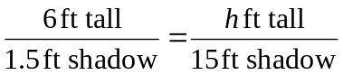

Multiplying both sides by 15, we get h = 60. The tree is about 60 ft tall.

It may be helpful to recall some formulas for areas and volumes of a few basic shapes.

Areas
Rectangle Circle, radius r
Area: 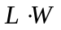 Area: πr²
Perimeter: 2L + 2W Circumference = 2πr
L
W
radius

Volumes
Rectangular Box Cylinder
Volume: L·W·H Volume: πr²H
W
L
H
H
r

Example 22
If a 12 inch diameter pizza requires 10 ounces of dough, how much dough is needed for a 16 inch pizza?

To answer this question, we need to consider how the weight of the dough will scale. The weight will be based on the volume of the dough. However, since both pizzas will be about the same thickness, the weight will scale with the area of the top of the pizza. We can find the area of each pizza using the formula for area of a circle, 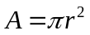:
A 12” pizza has radius 6 inches, so the area will be 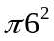 = about 113 square inches.
A 16” pizza has radius 8 inches, so the area will be 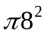 = about 201 square inches.

Notice that if both pizzas were 1 inch thick, the volumes would be 113 in³ and 201 in³ respectively, which are at the same ratio as the areas. As mentioned earlier, since the thickness is the same for both pizzas, we can safely ignore it.

We can now set up a proportion to find the weight of the dough for a 16” pizza:
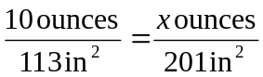 Multiply both sides by 201
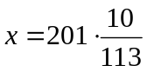 = about 17.8 ounces of dough for a 16” pizza.
It is interesting to note that while the diameter is 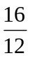 = 1.33 times larger, the dough required, which scales with area, is 1.33² = 1.78 times larger.

Example 23
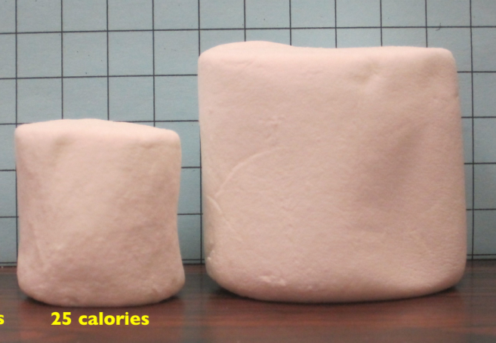
A company makes regular and jumbo marshmallows. The regular marshmallow has 25 calories. How many calories will the jumbo marshmallow have?

We would expect the calories to scale with volume. Since the marshmallows have cylindrical shapes, we can use that formula to find the volume. From the grid in the image, we can estimate the radius and height of each marshmallow.
Photo courtesy Christopher Danielson

The regular marshmallow appears to have a diameter of about 3.5 units, giving a radius of 1.75 units, and a height of about 3.5 units. The volume is about 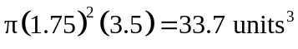.

The jumbo marshmallow appears to have a diameter of about 5.5 units, giving a radius of 2.75 units, and a height of about 5 units. The volume is about 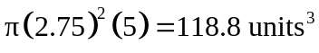.

We could now set up a proportion, or use rates. The regular marshmallow has 25 calories for 33.7 cubic units of volume. The jumbo marshmallow will have:
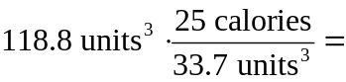 88.1 calories

It is interesting to note that while the diameter and height are about 1.5 times larger for the jumbo marshmallow, the volume and calories are about 1.5³ = 3.375 times larger.

Try it Now 5
A website says that you’ll need 48 fifty-pound bags of sand to fill a sandbox that measure 8ft by 8ft by 1ft. How many bags would you need for a sandbox 6ft by 4ft by 1ft?

Problem Solving and Estimating
Finally, we will bring together the mathematical tools we’ve reviewed, and use them to approach more complex problems. In many problems, it is tempting to take the given information, plug it into whatever formulas you have handy, and hope that the result is what you were supposed to find. Chances are, this approach has served you well in other math classes.

This approach does not work well with real life problems. Instead, problem solving is best approached by first starting at the end: identifying exactly what you are looking for. From there, you then work backwards, asking “what information and procedures will I need to find this?” Very few interesting questions can be answered in one mathematical step; often times you will need to chain together a solution pathway, a series of steps that will allow you to answer the question.

Problem Solving Process
- Identify the question you’re trying to answer.
- Work backwards, identifying the information you will need and the relationships you will use to answer that question.
- Continue working backwards, creating a solution pathway.
- If you are missing necessary information, look it up or estimate it. If you have unnecessary information, ignore it.
- Solve the problem, following your solution pathway.

In most problems we work, we will be approximating a solution, because we will not have perfect information. We will begin with a few examples where we will be able to approximate the solution using basic knowledge from our lives.

Example 24
How many times does your heart beat in a year?

This question is asking for the rate of heart beats per year. Since a year is a long time to measure heart beats for, if we knew the rate of heart beats per minute, we could scale that quantity up to a year. So the information we need to answer this question is heart beats per minute. This is something you can easily measure by counting your pulse while watching a clock for a minute.
Suppose you count 80 beats in a minute. To convert this beats per year:

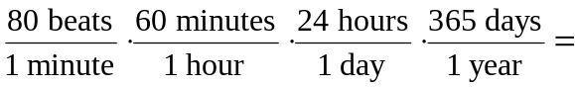 42,048,000 beats per year

Example 25
How thick is a single sheet of paper? How much does it weigh?

While you might have a sheet of paper handy, trying to measure it would be tricky. Instead we might imagine a stack of paper, and then scale the thickness and weight to a single sheet. If you’ve ever bought paper for a printer or copier, you probably bought a ream, which contains 500 sheets. We could estimate that a ream of paper is about 2 inches thick and weighs about 5 pounds. Scaling these down,
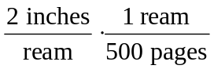 = 0.004 inches per sheet
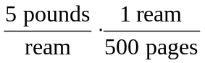 = 0.01 pounds per sheet, or 0.16 ounces per sheet.

Example 26
A recipe for zucchini muffins states that it yields 12 muffins, with 250 calories per muffin. You instead decide to make mini-muffins, and the recipe yields 20 muffins. If you eat 4, how many calories will you consume?

There are several possible solution pathways to answer this question. We will explore one.

To answer the question of how many calories 4 mini-muffins will contain, we would want to know the number of calories in each mini-muffin. To find the calories in each mini-muffin, we could first find the total calories for the entire recipe, then divide it by the number of mini-muffins produced. To find the total calories for the recipe, we could multiply the calories per standard muffin by the number per muffin. Notice that this produces a multi-step solution pathway. It is often easier to solve a problem in small steps, rather than trying to find a way to jump directly from the given information to the solution.

We can now execute our plan:
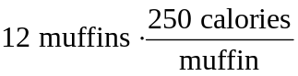 = 3000 calories for the whole recipe
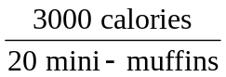 gives 150 calories per mini-muffin
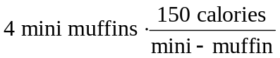 totals 600 calories consumed.

Example 27
You need to replace the boards on your deck. About how much will the materials cost?

There are two approaches we could take to this problem: 1) estimate the number of boards we will need and find the cost per board, or 2) estimate the area of the deck and find the approximate cost per square foot for deck boards. We will take the latter approach.

For this solution pathway, we will be able to answer the question if we know the cost per square foot for decking boards and the square footage of the deck. To find the cost per square foot for decking boards, we could compute the area of a single board, and divide it into the cost for that board. We can compute the square footage of the deck using geometric formulas. So first we need information: the dimensions of the deck, and the cost and dimensions of a single deck board.

Suppose that measuring the deck, it is rectangular, measuring 16 ft by 24 ft, for a total area of 384 ft².
From a visit to the local home store, you find that an 8 foot by 4 inch cedar deck board costs about $7.50. The area of this board, doing the necessary conversion from inches to feet, is:
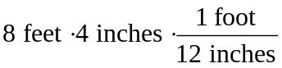 = 2.667 ft². The cost per square foot is then
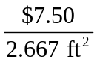 = $2.8125 per ft².

This will allow us to estimate the material cost for the whole 384 ft² deck
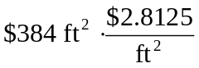 = $1080 total cost.

Of course, this cost estimate assumes that there is no waste, which is rarely the case. It is common to add at least 10% to the cost estimate to account for waste.

Example 28
Is it worth buying a Hyundai Sonata hybrid instead the regular Hyundai Sonata?

To make this decision, we must first decide what our basis for comparison will be. For the purposes of this example, we’ll focus on fuel and purchase costs, but environmental impacts and maintenance costs are other factors a buyer might consider.

It might be interesting to compare the cost of gas to run both cars for a year. To determine this, we will need to know the miles per gallon both cars get, as well as the number of miles we expect to drive in a year. From that information, we can find the number of gallons required from a year. Using the price of gas per gallon, we can find the running cost.

From Hyundai’s website, the 2013 Sonata will get 24 miles per gallon (mpg) in the city, and 35 mpg on the highway. The hybrid will get 35 mpg in the city, and 40 mpg on the highway.

An average driver drives about 12,000 miles a year. Suppose that you expect to drive about 75% of that in the city, so 9,000 city miles a year, and 3,000 highway miles a year.

We can then find the number of gallons each car would require for the year.

Sonata:
= 460.7 gallons
Hybrid:
= 332.1 gallons

If gas in your area averages about $3.50 per gallon, we can use that to find the running cost:

Sonata: 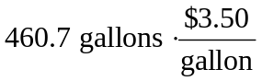 = $1612.45
Hybrid: 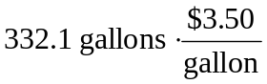 = $1162.35

The hybrid will save $450.10 a year. The gas costs for the hybrid are about 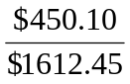 = 0.279 = 27.9% lower than the costs for the standard Sonata.

While both the absolute and relative comparisons are useful here, they still make it hard to answer the original question, since “is it worth it” implies there is some tradeoff for the gas savings. Indeed, the hybrid Sonata costs about $25,850, compared to the base model for the regular Sonata, at $20,895.

To better answer the “is it worth it” question, we might explore how long it will take the gas savings to make up for the additional initial cost. The hybrid costs $4965 more. With gas savings of $451.10 a year, it will take about 11 years for the gas savings to make up for the higher initial costs.

We can conclude that if you expect to own the car 11 years, the hybrid is indeed worth it. If you plan to own the car for less than 11 years, it may still be worth it, since the resale value of the hybrid may be higher, or for other non-monetary reasons. This is a case where math can help guide your decision, but it can’t make it for you.

Try it Now 6
If traveling from Seattle, WA to Spokane WA for a three-day conference, does it make more sense to drive or fly?

Try it Now Answers
1. The sale price is $799(0.70) = $559.30. After tax, the price is $559.30(1.092) = $610.76
2. 2001-2002: Absolute change: $0.43 trillion. Relative change: 7.45%
2005-2006: Absolute change: $0.54 trillion. Relative change: 6.83%
2005-2006 saw a larger absolute increase, but a smaller relative increase.
3. Without more information, it is hard to judge these arguments. This is compounded by the complexity of Medicare. As it turns out, the $716 billion is not a cut in current spending, but a cut in future increases in spending, largely reducing future growth in health care payments. In this case, at least the numerical claims in both statements could be considered at least partially true. Here is one source of more information if you’re interested: http://factcheck.org/2012/08/a-campaign-full-of-mediscare/
4. 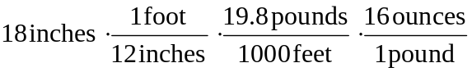 ≈ 0.475 ounces

Try it Now Answers Continued
5. The original sandbox has volume 64 ft³. The smaller sandbox has volume 24ft³.
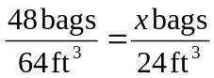 results in x = 18 bags.

6. There is not enough information provided to answer the question, so we will have to make some assumptions, and look up some values.
Assumptions:
a) We own a car. Suppose it gets 24 miles to the gallon. We will only consider gas cost.
b) We will not need to rent a car in Spokane, but will need to get a taxi from the airport to the conference hotel downtown and back.
c) We can get someone to drop us off at the airport, so we don’t need to consider airport parking.
d) We will not consider whether we will lose money by having to take time off work to drive.

Values looked up (your values may be different)
a) Flight cost: $184
b) Taxi cost: $25 each way (estimate, according to hotel website)
c) Driving distance: 280 miles each way
d) Gas cost: $3.79 a gallon

Cost for flying: $184 flight cost + $50 in taxi fares = $234.
Cost for driving: 560 miles round trip will require 23.3 gallons of gas, costing $88.31.

Based on these assumptions, driving is cheaper. However, our assumption that we only include gas cost may not be a good one. Tax law allows you deduct $0.55 (in 2012) for each mile driven, a value that accounts for gas as well as a portion of the car cost, insurance, maintenance, etc. Based on this number, the cost of driving would be $319.

Exercises

- Out of 230 racers who started the marathon, 212 completed the race, 14 gave up, and 4 were disqualified. What percentage did not complete the marathon?

- Patrick left an $8 tip on a $50 restaurant bill. What percent tip is that?

- Ireland has a 23% VAT (value-added tax, similar to a sales tax). How much will the VAT be on a purchase of a €250 item?

- Employees in 2012 paid 4.2% of their gross wages towards social security (FICA tax), while employers paid another 6.2%. How much will someone earning $45,000 a year pay towards social security out of their gross wages?

- A project on Kickstarter.com was aiming to raise $15,000 for a precision coffee press. They ended up with 714 supporters, raising 557% of their goal. How much did they raise?

- Another project on Kickstarter for an iPad stylus raised 1,253% of their goal, raising a total of $313,490 from 7,511 supporters. What was their original goal?

- The population of a town increased from 3,250 in 2008 to 4,300 in 2010. Find the absolute and relative (percent) increase.

- The number of CDs sold in 2010 was 114 million, down from 147 million the previous year. Find the absolute and relative (percent) decrease.

- A company wants to decrease their energy use by 15%.
  - If their electric bill is currently $2,200 a month, what will their bill be if they’re successful?
  - If their next bill is $1,700 a month, were they successful? Why or why not?

- A store is hoping an advertising campaign will increase their number of customers by 30%. They currently have about 80 customers a day.
  - How many customers will they have if their campaign is successful?
  - If they increase to 120 customers a day, were they successful? Why or why not?

- An article reports “attendance dropped 6% this year, to 300.” What was the attendance before the drop?

- An article reports “sales have grown by 30% this year, to $200 million.” What were sales before the growth?

- The Walden University had 47,456 students in 2010, while Kaplan University had 77,966 students. Complete the following statements:
  - Kaplan’s enrollment was ___% larger than Walden’s.
  - Walden’s enrollment was ___% smaller than Kaplan’s.
  - Walden’s enrollment was ___% of Kaplan’s.

- In the 2012 Olympics, Usain Bolt ran the 100m dash in 9.63 seconds. Jim Hines won the 1968 Olympic gold with a time of 9.95 seconds.
  - Bolt’s time was ___% faster than Hines’.
  - Hine’ time was ___% slower than Bolt’s.
  - Hine’ time was ___% of Bolt’s.

- A store has clearance items that have been marked down by 60%. They are having a sale, advertising an additional 30% off clearance items. What percent of the original price do you end up paying?

- Which is better: having a stock that goes up 30% on Monday than drops 30% on Tuesday, or a stock that drops 30% on Monday and goes up 30% on Tuesday? In each case, what is the net percent gain or loss?

- Are these two claims equivalent, in conflict, or not comparable because they’re talking about different things?
  - “16.3% of Americans are without health insurance”
  - “only 55.9% of adults receive employer provided health insurance”

- Are these two claims equivalent, in conflict, or not comparable because they’re talking about different things?
  - “We mark up the wholesale price by 33% to come up with the retail price”
  - “The store has a 25% profit margin”

- Are these two claims equivalent, in conflict, or not comparable because they’re talking about different things?
  - “Every year since 1950, the number of American children gunned down has doubled.”
  - “The number of child gunshot deaths has doubled from 1950 to 1994.”

- Are these two claims equivalent, in conflict, or not comparable because they’re talking about different things?
  - “75 percent of the federal health care law’s taxes would be paid by those earning less than $120,000 a year”
  - “76 percent of those who would pay the penalty [health care law’s taxes] for not having insurance in 2016 would earn under $120,000”

- Are these two claims equivalent, in conflict, or not comparable because they’re talking about different things?
  - “The school levy is only a 0.1% increase of the property tax rate.”
  - “This new levy is a 12% tax hike, raising our total rate to $9.33 per $1000 of value.”

- Are the values compared in this statement comparable or not comparable? “Guns have murdered more Americans here at home in recent years than have died on the battlefields of Iraq and Afghanistan. In support of the two wars, more than 6,500 American soldiers have lost their lives. During the same period, however, guns have been used to murder about 100,000 people on American soil”

- A high school currently has a 30% dropout rate. They’ve been tasked to decrease that rate by 20%. Find the equivalent percentage point drop.

- A politician’s support grew from 42% by 3 percentage points to 45%. What percent (relative) change is this?

- Marcy has a 70% average in her class going into the final exam. She says "I need to get a 100% on this final so I can raise my score to 85%." Is she correct?

- Suppose you have one quart of water/juice mix that is 50% juice, and you add 2 quarts of juice. What percent juice is the final mix?

- Find a unit rate: You bought 10 pounds of potatoes for $4.

- Find a unit rate: Joel ran 1500 meters in 4 minutes, 45 seconds.

- Solve: 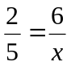.

- Solve: 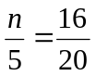.

- A crepe recipe calls for 2 eggs, 1 cup of flour, and 1 cup of milk. How much flour would you need if you use 5 eggs?

- An 8ft length of 4 inch wide crown molding costs $14. How much will it cost to buy 40ft of crown molding?

- Four 3-megawatt wind turbines can supply enough electricity to power 3000 homes. How many turbines would be required to power 55,000 homes?

- A highway had a landslide, where 3,000 cubic yards of material fell on the road, requiring 200 dump truck loads to clear. On another highway, a slide left 40,000 cubic yards on the road. How many dump truck loads would be needed to clear this slide?

- Convert 8 feet to inches.

- Convert 6 kilograms to grams.

- A wire costs $2 per meter. How much will 3 kilometers of wire cost?

- Sugar contains 15 calories per teaspoon. How many calories are in 1 cup of sugar?

- A car is driving at 100 kilometers per hour. How far does it travel in 2 seconds?

- A chain weighs 10 pounds per foot. How many ounces will 4 inches weigh?

- The table below gives data on three movies. Gross earnings is the amount of money the movie brings in. Compare the net earnings (money made after expenses) for the three movies.
Movie | Release Date | Budget | Gross earnings
Saw | 10/29/2004 | $1,200,000 | $103,096,345
Titanic | 12/19/1997 | $200,000,000 | $1,842,879,955
Jurassic Park | 6/11/1993 | $63,000,000 | $923,863,984

- For the movies in the previous problem, which provided the best return on investment?

- The population of the U.S. is about 309,975,000, covering a land area of 3,717,000 square miles. The population of India is about 1,184,639,000, covering a land area of 1,269,000 square miles. Compare the population densities of the two countries.

- The GDP (Gross Domestic Product) of China was $5,739 billion in 2010, and the GDP of Sweden was $435 billion. The population of China is about 1,347 million, while the population of Sweden is about 9.5 million. Compare the GDP per capita of the two countries.

- In June 2012, Twitter was reporting 400 million tweets per day. Each tweet can consist of up to 140 characters (letter, numbers, etc.). Create a comparison to help understand the amount of tweets in a year by imagining each character was a drop of water and comparing to filling something up.

- The photo sharing site Flickr had 2.7 billion photos in June 2012. Create a comparison to understand this number by assuming each picture is about 2 megabytes in size, and comparing to the data stored on other media like DVDs, iPods, or flash drives.

- Your chocolate milk mix says to use 4 scoops of mix for 2 cups of milk. After pouring in the milk, you start adding the mix, but get distracted and accidentally put in 5 scoops of mix. How can you adjust the mix if:
  - There is still room in the cup?
  - The cup is already full?

- A recipe for sabayon calls for 2 egg yolks, 3 tablespoons of sugar, and ¼ cup of white wine. After cracking the eggs, you start measuring the sugar, but accidentally put in 4 tablespoons of sugar. How can you compensate?

- The Deepwater Horizon oil spill resulted in 4.9 million barrels of oil spilling into the Gulf of Mexico. Each barrel of oil can be processed into about 19 gallons of gasoline. How many cars could this have fueled for a year? Assume an average car gets 20 miles to the gallon, and drives about 12,000 miles in a year.

- The store is selling lemons at 2 for $1. Each yields about 2 tablespoons of juice. How much will it cost to buy enough lemons to make a 9-inch lemon pie requiring ½ cup of lemon juice?

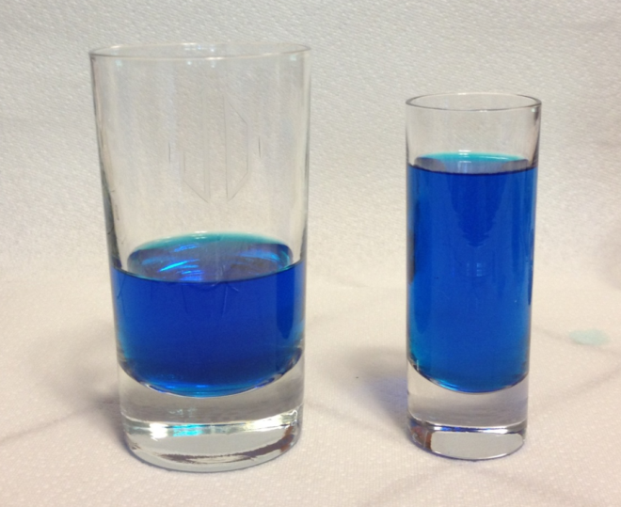
- A piece of paper can be made into a cylinder in two ways: by joining the short sides together, or by joining the long sides together. Which cylinder would hold more? How much more?

- Which of these glasses contains more liquid? How much more?

In the next 4 questions, estimate the values by making reasonable approximations for unknown values, or by doing some research to find reasonable values.

- Estimate how many gallons of water you drink in a year.

- Estimate how many times you blink in a day.

- How much does the water in a 6-person hot tub weigh?

- How many gallons of paint would be needed to paint a two-story house 40 ft long and 30 ft wide?

- During the landing of the Mars Science Laboratory Curiosity, it was reported that the signal from the rover would take 14 minutes to reach earth. Radio signals travel at the speed of light, about 186,000 miles per second. How far was Mars from Earth when Curiosity landed?
- It is estimated that a driver takes, on average, 1.5 seconds from seeing an obstacle to reacting by applying the brake or swerving. How far will a car traveling at 60 miles per hour travel (in feet) before the driver reacts to an obstacle?

- The flash of lightning travels at the speed of light, which is about 186,000 miles per second. The sound of lightning (thunder) travels at the speed of sound, which is about 750 miles per hour.
  - If you see a flash of lightning, then hear the thunder 4 seconds later, how far away is the lightning?
  - Now let’s generalize that result. Suppose it takes n seconds to hear the thunder after a flash of lightning. How far away is the lightning, in terms of n?

- Sound travels about 750 miles per hour. If you stand in a parking lot near a building and sound a horn, you will hear an echo.
  - Suppose it takes about ½ a second to hear the echo. How far away is the building?
  - Now let’s generalize that result. Suppose it takes n seconds to hear the echo. How far away is the building, in terms of n?

- It takes an air pump 5 minutes to fill a twin sized air mattress (39 by 8.75 by 75 inches). How long will it take to fill a queen sized mattress (60 by 8.75 by 80 inches)?

- It takes your garden hose 20 seconds to fill your 2-gallon watering can. How long will it take to fill
- An inflatable pool measuring 3 feet wide, 8 feet long, and 1 foot deep.
- A circular inflatable pool 13 feet in diameter and 3 feet deep.

- You want to put a 2" thick layer of topsoil for a new 20'x30' garden. The dirt store sells by the cubic yards. How many cubic yards will you need to order?

- A box of Jell-O costs $0.50, and makes 2 cups. How much would it cost to fill a swimming pool 4 feet deep, 8 feet wide, and 12 feet long with Jell-O? (1 cubic foot is about 7.5 gallons)

- You read online that a 15 ft by 20 ft brick patio would cost about $2,275 to have professionally installed. Estimate the cost of having a 18 by 22 ft brick patio installed.
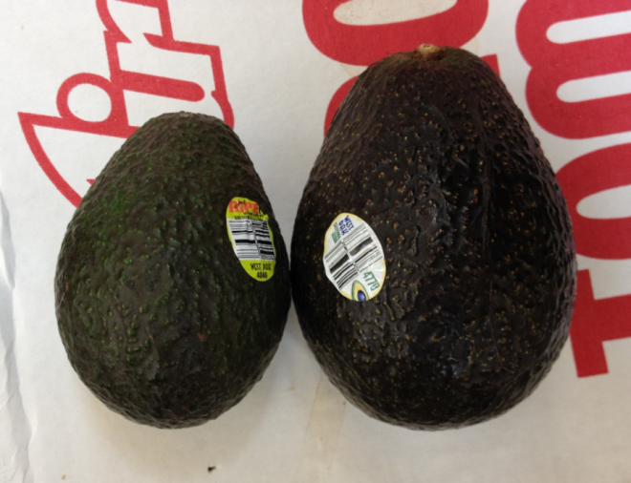
- I was at the store, and saw two sizes of avocados being sold. The regular size sold for $0.88 each, while the jumbo ones sold for $1.68 each. Which is the better deal?

Nutrition Facts
Serving Size: 1 cup, halves (99 g)
Servings per Container: about 2
Amount Per Serving
Calories 684 Calories from Fat 596
% Daily Value*
Total Fat 71g 110%
Saturated Fat 6g 31%
Trans Fat
Cholesterol 0mg 0%

- The grocery store has bulk pecans on sale, which is great since you’re planning on making 10 pecan pies for a wedding. Your recipe calls for 1¾ cups pecans per pie. However, in the bulk section there’s only a scale available, not a measuring cup. You run over to the baking aisle and find a bag of pecans, and look at the nutrition label to gather some info. How many pounds of pecans should you buy?

Nutrition Facts
Serving Size: 8 fl oz (240 mL)
Servings Per Container: about 2.5
Amount Per Serving
Calories 110
% Daily Value*
Total Fat 0g 0%
Sodium 70mg 3%
Total Carbohydrate 31g 10%
Sugars 30g
Protein 0g

- Soda is often sold in 20 ounce bottles. The nutrition label for one of these bottles is shown to the right. A packet of sugar (the kind they have at restaurants for your coffee or tea) typically contain 4 grams of sugar in the U.S. Drinking a 20 oz soda is equivalent to eating how many packets of sugar?

For the next set of questions, first identify the information you need to answer the question, and then turn to the end of the section to find that information. The details may be imprecise; answer the question the best you can with the provided information. Be sure to justify your decision.

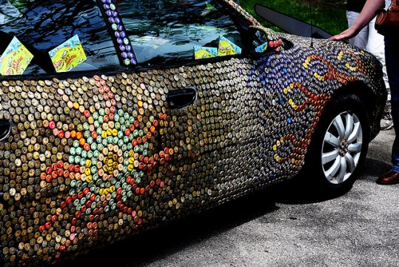
- You’re planning on making 6 meatloafs for a party. You go to the store to buy breadcrumbs, and see they are sold by the canister. How many canisters do you need to buy?

- Your friend wants to cover their car in bottle caps, like in this picture. How many bottle caps are you going to need?

- You need to buy some chicken for dinner tonight. You found an ad showing that the store across town has it on sale for $2.99 a pound, which is cheaper than your usual neighborhood store, which sells it for $3.79 a pound. Is it worth the extra drive?

- I have an old gas furnace, and am considering replacing it with a new, high efficiency model. Is upgrading worth it?

- Janine is considering buying a water filter and a reusable water bottle rather than buying bottled water. Will doing so save her money?

- Marcus is considering going car-free to save money and be more environmentally friendly. Is this financially a good decision?

For the next set of problems, research or make educated estimates for any unknown quantities needed to answer the question.

- You want to travel from Tacoma, WA to Chico, CA for a wedding. Compare the costs and time involved with driving, flying, and taking a train. Assume that if you fly or take the train you’ll need to rent a car while you’re there. Which option is best?

- You want to paint the walls of a 6ft by 9ft storage room that has one door and one window. You want to put on two coats of paint. How many gallons and/or quarts of paint should you buy to paint the room as cheaply as possible?

- A restaurant in New York tiled their floor with pennies. Just for the materials, is this more expensive than using a more traditional material like ceramic tiles? If each penny has to be laid by hand, estimate how long it would take to lay the pennies for a 12ft by 10ft room. Considering material and labor costs, are pennies a cost-effective replacement for ceramic tiles?

- You are considering taking up part of your back yard and turning it into a vegetable garden, to grow broccoli, tomatoes, and zucchini. Will doing so save you money, or cost you more than buying vegetables from the store?

- Barry is trying to decide whether to keep his 1993 Honda Civic with 140,000 miles, or trade it in for a used 2008 Honda Civic. Consider gas, maintenance, and insurance costs in helping him make a decision.

- Some people claim it costs more to eat vegetarian, while some claim it costs less. Examine your own grocery habits, and compare your current costs to the costs of switching your diet (from omnivore to vegetarian or vice versa as appropriate). Which diet is more cost effective based on your eating habits?

Info for the breadcrumbs question
Nutrition Facts
Serving Size: 1/3 cup (30g)
Servings per Container: about 14
Amount Per Serving
Calories 110 Calories from Fat 15
% Daily Value*
Total Fat 1.5g 2%

How much breadcrumbs does the recipe call for?
It calls for 1½ cups of breadcrumbs.
How many meatloafs does the recipe make?
It makes 1 meatloaf.
How many servings does that recipe make?
It says it serves 8.
How big is the canister?
It is cylindrical, 3.5 inches across and
7 inches tall.
What is the net weight of the contents of 1 canister?
15 ounces.
How much does a cup of breadcrumbs weigh?
I’m not sure, but maybe something from the nutritional label will help.
How much does a canister cost? $2.39

Info for bottle cap car
What kind of car is that?
A 1993 Honda Accord.
How big is that car / what are the dimensions? Here is some details from MSN autos:
Weight: 2800lb Length: 185.2 in Width: 67.1 in Height: 55.2 in
How much of the car was covered with caps?
Everything but the windows and the underside.
How big is a bottle cap?
Caps are 1 inch in diameter.

Info for chicken problem
How much chicken will you be buying?
Four pounds
How far are the two stores?
My neighborhood store is 2.2 miles away, and takes about 7 minutes. The store across town is 8.9 miles away, and takes about 25 minutes.
What kind of mileage does your car get?
It averages about 24 miles per gallon in the city.
How many gallons does your car hold?
About 14 gallons
How much is gas?
About $3.69/gallon right now.

Info for furnace problem
How efficient is the current furnace?
It is a 60% efficient furnace.
How efficient is the new furnace?
It is 94% efficient.
What is your gas bill?
Here is the history for 2 years:
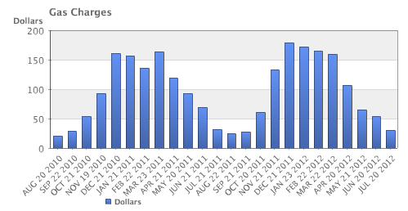
How much do you pay for gas?
There is $10.34 base charge, plus $0.39097 per Therm for a delivery charge, and $0.65195 per Therm for cost of gas.
How much gas do you use?
Here is the history for 2 years:
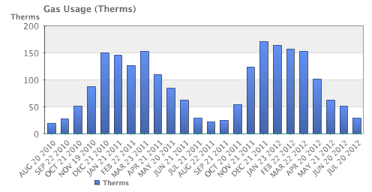
How much does the new furnace cost?
It will cost $7,450.
How long do you plan to live in the house?
Probably at least 15 years.

Info for water filter problem
How much water does Janine drink in a day?
She normally drinks 3 bottles a day, each 16.9 ounces.
How much does a bottle of water cost?
She buys 24-packs of 16.9 ounce bottles for $3.99.
How much does a reusable water bottle cost?
About $10.
How long does a reusable water bottle last?
Basically forever (or until you lose it).
How much does a water filter cost? How much water will they filter?
- A faucet-mounted filter costs about $28. Refill filters cost about $33 for a 3-pack. The box says each filter will filter up to 100 gallons (378 liters)
- A water filter pitcher costs about $22. Refill filters cost about $20 for a 4-pack. The box says each filter lasts for 40 gallons or 2 months
- An under-sink filter costs $130. Refill filters cost about $60 each. The filter lasts for 500 gallons.

Info for car-free problem
Where does Marcus currently drive? He:
- Drives to work 5 days a week, located 4 miles from his house.
- Drives to the store twice a week, located 7 miles from his house.
- Drives to other locations on average 5 days a week, with locations ranging from 1 mile to 20 miles.
- Drives to his parent’s house 80 miles away once a month.
How will he get to these locations without a car?
- For work, he can walk when it’s sunny and he gets up early enough. Otherwise he can take a bus, which takes about 20 minutes
- For the store, he can take a bus, which takes about 35 minutes.
- Some of the other locations he can bus to. Sometimes he’ll be able to get a friend to pick him up. A few locations he is able to walk to. A couple locations are hard to get to by bus, but there is a ZipCar (short term car rental) location within a few blocks.
- He’ll need to get a ZipCar to visit his parents.
How much does gas cost?
About $3.69/gallon.
How much does he pay for insurance and maintenance?
- He pays $95/month for insurance.
- He pays $30 every 3 months for an oil change, and has averaged about $300/year for other maintenance costs.
How much is he paying for the car?
- He’s paying $220/month on his car loan right now, and has 3 years left on the loan.
- If he sold the car, he’d be able to make enough to pay off the loan.
- If he keeps the car, he’s planning on trading the car in for a newer model in a couple years.
What mileage does his car get?
About 26 miles per gallon on average.
How much does a bus ride cost?
$2.50 per trip, or $90 for an unlimited monthly pass.
How much does a ZipCar rental cost?
- The “occasional driving plan”: $25 application fee and $60 annual fee, with no monthly commitment. Monday-Thursday the cost is $8/hour, or $72 per day. Friday-Sunday the cost is $8/hour or $78/day. Gas, insurance, and 180 miles are included in the cost. Additional miles are $0.45/mile.
- The “extra value plan”: Same as above, but with a $50 monthly commitment, getting you a 10% discount on the usage costs.

Extension: Taxes
Governments collect taxes to pay for the services they provide. In the United States, federal income taxes help fund the military, the environmental protection agency, and thousands of other programs. Property taxes help fund schools. Gasoline taxes help pay for road improvements. While very few people enjoy paying taxes, they are necessary to pay for the services we all depend upon.

Taxes can be computed in a variety of ways, but are typically computed as a percentage of a sale, of one’s income, or of one’s assets.

Example 1
The sales tax rate in a city is 9.3%. How much sales tax will you pay on a $140 purchase?

The sales tax will be 9.3% of $140. To compute this, we multiply $140 by the percent written as a decimal: $140(0.093) = $13.02.

When taxes are not given as a fixed percentage rate, sometimes it is necessary to calculate the effective rate.

Effective rate
The effective tax rate is the equivalent percent rate of the tax paid out of the dollar amount the tax is based on.

Example 2
Joan paid $3,200 in property taxes on her house valued at $215,000 last year. What is the effective tax rate?

We can compute the equivalent percentage: 3200/215000 = 0.01488, or about 1.49% effective rate.

Taxes are often referred to as progressive, regressive, or flat.

Tax categories
A flat tax, or proportional tax, charges a constant percentage rate.
A progressive tax increases the percent rate as the base amount increases.
A regressive tax decreases the percent rate as the base amount increases.

Example 3
The United States federal income tax on earned wages is an example of a progressive tax. People with a higher wage income pay a higher percent tax on their income.

For a single person in 2011, adjusted gross income (income after deductions) under $8,500 was taxed at 10%. Income over $8,500 but under $34,500 was taxed at 15%.

A person earning $10,000 would pay 10% on the portion of their income under $8,500, and 15% on the income over $8,500, so they’d pay:
8500(0.10) = 850 10% of $8500
1500(0.15) = 225 15% of the remaining $1500 of income
Total tax: = $1075

The effective tax rate paid is 1075/10000 = 10.75%

A person earning $30,000 would also pay 10% on the portion of their income under $8,500, and 15% on the income over $8,500, so they’d pay:
8500(0.10) = 850 10% of $8500
21500(0.15) = 3225 15% of the remaining $21500 of income
Total tax: = $4075

The effective tax rate paid is 4075/30000 = 13.58%.

Notice that the effective rate has increased with income, showing this is a progressive tax.

Example 4
A gasoline tax is a flat tax when considered in terms of consumption, a tax of, say, $0.30 per gallon is proportional to the amount of gasoline purchased. Someone buying 10 gallons of gas at $4 a gallon would pay $3 in tax, which is $3/$40 = 7.5%. Someone buying 30 gallons of gas at $4 a gallon would pay $9 in tax, which is $9/$120 = 7.5%, the same effective rate.

However, in terms of income, a gasoline tax is often considered a regressive tax. It is likely that someone earning $30,000 a year and someone earning $60,000 a year will drive about the same amount. If both pay $60 in gasoline taxes over a year, the person earning $30,000 has paid 0.2% of their income, while the person earning $60,000 has paid 0.1% of their income in gas taxes.

Try it Now 1
A sales tax is a fixed percentage tax on a person’s purchases. Is this a flat, progressive, or regressive tax?

Try it Now Answers
1. While sales tax is a flat percentage rate, it is often considered a regressive tax for the same reasons as the gasoline tax.

Income Taxation
Many people have proposed various revisions to the income tax collection in the United States. Some, for example, have claimed that a flat tax would be fairer. Others call for revisions to how different types of income are taxed, since currently investment income is taxed at a different rate than wage income.

The following two projects will allow you to explore some of these ideas and draw your own conclusions.

Project 1: Flat tax, Modified Flat Tax, and Progressive Tax.

Imagine the country is made up of 100 households. The federal government needs to collect $800,000 in income taxes to be able to function. The population consists of 6 groups:

Group A: 20 households that earn $12,000 each
Group B: 20 households that earn $29,000 each
Group C: 20 households that earn $50,000 each
Group D: 20 households that earn $79,000 each
Group E: 15 households that earn $129,000 each
Group F: 5 households that earn $295,000 each

This scenario is roughly proportional to the actual United States population and tax needs. We are going to determine new income tax rates.

The first proposal we’ll consider is a flat tax – one where every income group is taxed at the same percentage tax rate.

1) Determine the total income for the population (all 100 people together)

2) Determine what flat tax rate would be necessary to collect enough money.

The second proposal we’ll consider is a modified flat-tax plan, where everyone only pays taxes on any income over $20,000. So, everyone in group A will pay no taxes. Everyone in group B will pay taxes only on $9,000.

3) Determine the total taxable income for the whole population

4) Determine what flat tax rate would be necessary to collect enough money in this modified system

5) Complete this table for both the plans
 |  | Flat Tax Plan |  | Modified Flat Tax Plan
Group | Income per household | Income tax per household | Income after taxes | Income tax per household | Income after taxes
A | $12,000
B | $29,000
C | $50,000
D | $79,000
E | $129,000
F | $295,000

The third proposal we’ll consider is a progressive tax, where lower income groups are taxed at a lower percent rate, and higher income groups are taxed at a higher percent rate. For simplicity, we’re going to assume that a household is taxed at the same rate on all their income.

6) Set progressive tax rates for each income group to bring in enough money. There is no one right answer here – just make sure you bring in enough money!
Group | Income per household | Tax rate (%) | Income tax per household | Total tax collected for all households | Income after taxes per household
A | $12,000
B | $29,000
C | $50,000
D | $79,000
E | $129,000
F | $295,000
 |  |  |  | This better total to $800,000

7) Discretionary income is the income people have left over after paying for necessities like rent, food, transportation, etc. The cost of basic expenses does increase with income, since housing and car costs are higher, however usually not proportionally. For each income group, estimate their essential expenses, and calculate their discretionary income. Then compute the effective tax rate for each plan relative to discretionary income rather than income.

Group | Income per household | Discretionary Income (estimated) | Effective rate, flat | Effective rate, modified | Effective rate, progressive
A | $12,000
B | $29,000
C | $50,000
D | $79,000
E | $129,000
F | $295,000

8) Which plan seems the most fair to you? Which plan seems the least fair to you? Why?

Project 2: Calculating Taxes.
Visit www.irs.gov, and download the most recent version of forms 1040, and schedules A, B, C, and D.

Scenario 1: Calculate the taxes for someone who earned $60,000 in standard wage income (W-2 income), has no dependents, and takes the standard deduction.

Scenario 2: Calculate the taxes for someone who earned $20,000 in standard wage income, $40,000 in qualified dividends, has no dependents, and takes the standard deduction. (Qualified dividends are earnings on certain investments such as stocks.)

Scenario 3: Calculate the taxes for someone who earned $60,000 in small business income, has no dependents, and takes the standard deduction.

Based on these three scenarios, what are your impressions of how the income tax system treats these different forms of income (wage, dividends, and business income)?

Scenario 4: To get a more realistic sense for calculating taxes, you’ll need to consider itemized deductions. Calculate the income taxes for someone with the income and expenses listed below.

Married with 2 children, filing jointly
Wage income: $50,000 combined
Paid sales tax in Washington State
Property taxes paid: $3200
Home mortgage interest paid: $4800
Charitable gifts: $1200

http://www.factcheck.org/cheney_edwards_mangle_facts.html
http://tvtropes.org/pmwiki/pmwiki.php/Main/LiesDamnedLiesAndStatistics
http://www.whitehouse.gov/sites/default/files/omb/budget/fy2013/assets/hist07z1.xls
https://www.cia.gov/library/publications/the-world-factbook/rankorder/2042rank.html
http://data.worldbank.org/indicator/SP.POP.TOTL
http://www.cnn.com/2010/SHOWBIZ/Music/07/19/cd.digital.sales/index.html
http://www.cnn.com/2012/06/27/politics/btn-health-care/index.html
http://www.politico.com/news/stories/0712/78134.html
http://factcheck.org/2012/07/twisting-health-care-taxes/
http://www.northjersey.com/news/opinions/lautenberg_073112.html?c=y&page=2
http://www.the-numbers.com/movies/records/budgets.php
http://vimeo.com/42501010
http://vimeo.com/40377128
http://www.youtube.com/watch?v=DIkwefReHZc
http://www.youtube.com/watch?v=p9SABH7Yg9M
http://www.youtube.com/watch?v=62JMfv0tf3Q
Photo credit: http://www.flickr.com/photos/swayze/, CC-BY
http://www.notcot.com/archives/2009/06/floor-of-pennie.php

